Adventure in Iran

Dear friends

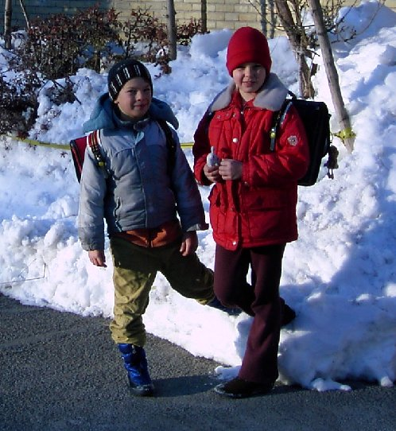
As you might know, since January 2005 my family and me are installed in Tehran (Iran) where I was offered a job with Nestle Iran! Surprised? Well, then read more to get (almost) everything from the beginning up to today.

It all started in September 2004, just about when I came back to Switzerland from my 5 month mission with Nestle Romania (where my job was to set up up the Purchasing Department): I was offered the job as Supply Chain Manager of Nestlé Iran. Ok., first I swallowed emptily, then I started searching for information about Iran. What country is this? Could a family live there? Shall we do this? What about schools? etc. There were hundreds of questions. At the end of October 2004 Sara and me went to Tehran to have a look for ourselves. To our surprise Iran was much "better" than expected. As an expatriate apparently there should not be any big problem to "survive" and to have a relatively good life - of course apart from the fact that there will be plenty of work. Well, as to me, I was told that they are not looking for somebody who wants to come here for holidays. And the assignment would be for something like 2-4 years, probably 3 years (in the mean time it has been decided that I should stay here in Iran until June 2008).

As we are adventurous people of course we accepted the challenge. We moved to Tehran at the end of January 2005, we found a very nice apartment, the kids go to the French school, Sara spends quite some time with other expat families, I have long, hard-working days (as expected), in the weekends we go to the mountains (skiing in winter, hiking in summer) etc.

What exactly am I doing in Tehran? Well, Nestle Iran was looking for a Supply Chain Manager. As Nestle is relatively new in Iran, there was nothing set up (no predecessor). It was and is my job to organise the structure, the team and the processes in the Supply Chain area. What does this include? It includes Demand and Supply Planning, Logistics, Transport, Customer Service, Sales Order Management, Clearance, Purchasing, Export, Warehouse, Distribution etc. A big field. And most of it was new to me (as I was "only" a buyer before). But everything could be learned. And then I had to teach it to the new staff. Since I arrived here, the department grew already from 5 to 13. So I am constantly coaching new team members. Additionally to the job as Supply Chain Manager I was also given the General Services as well as the job as Country Security Manager. Well, this means that I am not really underoccupied.

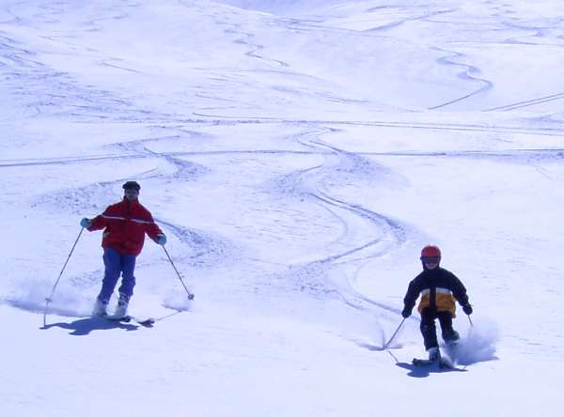
But it is extremely interesting and motivating to work in such a constructive and growing environment (in Nestle Switzerland the discussion was mainly about reduction of the number of employees). Here in Iran I can be part of an important Nestlé development in a market which has 70 million potential consumers. It is not always easy to work with the Iranians. They don't necessarily have the same business-oriented thinking, the same pro-activity, the same speed, the same mentality, the same result-orientation etc. as I was used to with my collaborators in Nestlé Switzerland. This means, that I have to spend a lot of time coaching the staff to get them aligned to business, to the "Nestlé way" etc. This is why we are now about 18 expatriates with Nestlé Iran. This will of course be reduced again as soon as we have some locals who can take over from us (this is also my job: to find a successor).

And the family? The kids (Silvia is 11 years, Reto is 9 years old) go to the French school here in Tehran. The school is only about 10 minutes (on foot) away from our apartment which is quite surprising in this big, 14-million inhabitants town. Sara brings them to school every morning and picks them up again after school. There are also extra-scholar activities for the kids: they play football (Reto), they went to Karate (both), they play tennis, play theatre (both), go horse-riding etc. They are not bored, this is for sure. They often visit their new school friends, or their friends come to our apartment. And they can enjoy the swimming-pool in our building (which is sharing with other residents, of course).
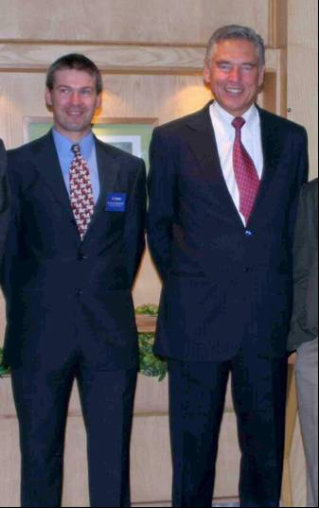
In July 2005 we had the visit of our big boss (the Chief Executive Officer of Nestlé SA), Mr. Brabeck, and a couple of other high ranking top Managers. This was quite an event. I had the priviledge (or the burden?) to have to give a presentation to our CEO. Fortunately – and quite surprisingly – I was not even extremely nervous for this event. There were some questions to which I was also able to give correct and concise answers. Ouff!

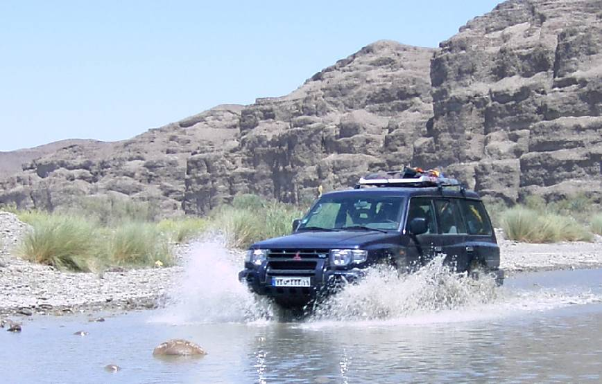
In the week-ends we often go to the mountains (as Swiss this is not a surprise). You can check the mountains out on the picture page on the internet (www.bubendorf.ch/iran/photos.htm). I was very often on the mountain Tochal right behind Teheran. This is a 5-6 hour hike up to 3970 meters. A fantastic experience was the 2-day trip on Damavand, the highest mountain (a volcano) in Iran with 5671 m above sea level. I could never imagine how thin the air can be at such an altitude. It was a tough hike, but on the top you forget immediately all the efforts to get up there (more information here: www.bubendorf.ch/iran/damavand.htm).

In March 2006 we made an interesting excursion with friends and our 4-wheel drive (Pajero) to the desert of Lut in the south of Iran. We even went as south as the Persian Gulf with ist long unpopulated beaches. Please also look at the special pages of this trip (www.bubendorf.ch/iran/Gavater.html).

As there is not much text in English on our Internet pages (time is missing!) I suggest that you have a look at our picture pages: www.bubendorf.ch/iran/photos.htm. This should be self-explaining.

Saluti and ciao and khodo hafaz

Thomas

